Week 9 CPSC 33000 .Net Programming

Programming Assignment 6

Directions:
- Install the Free Version of Microsoft SQL Express found on the Microsoft Website.
- Using Visual Studio and SQL Server Express, create the database described below. Follow the in-class example.
- Steps:
  - In Visual Studio, create a new Project, and give it a corresponding related name.
  - Make sure SQL Express is running
  - Create a New Database and call it Computer_Software or a related name.
  - Create a table (data structure) of every table. One table at a time.
  - In Microsoft WordPad, prepare the INSERT INTO series of queries for each table. Then create a new query, add all the INSERT INTO statements to the new query area, and execute it. Execute each set one at a time. Verify that the INSERT queries succeed before proceeding.
  - Finally, in the C# console application portion of the project, establish a database connection and then create and execute a select query to display all the data from each table. You will need five select queries, one for each table.
- When completed, upload your project to GitHub for grading.

Computer Software Database

The Computer Database is used to keep track of users, computers, and the software employees use to perform their jobs in the office or at home. Below, find the ER-Diagram describing the database structure, and further down, find a copy of the corresponding data.

ER Diagram
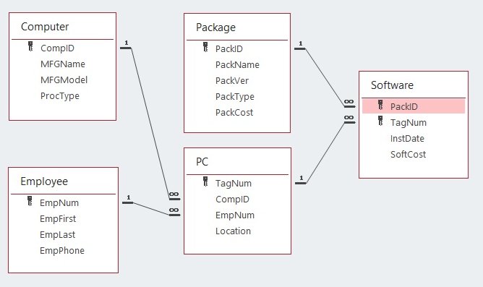

Data Type:

Data:

Computer
CompID MFGName MFGModel ProcType
B121 Bantam 48X 486DX
B221 Bantam 48D 486DX2
C007 Cody D1 486DX
M759 Lemmin GRL 486SX

Employee
EmpNum EmpFirst EmpLast EmpPhone
123 Melissa Mendez 874-736-8752
124 Ramon Alvarez 121-234-5462
562 Betty Feinstein 871-653-6723
611 Melissa Dinh 296-363-6452
745 Jonathan Smith 312-653-8234
823 Tina Duarte 708-234-7723

PC
TagNum CompID EmpNum Location
23556 C007 123 Accounting
32808 M759 611 Accounting
37691 B121 124 Sales
57772 C007 562 Info Systems
59836 B221 124 Home
63721 M759 611 Home
77740 M759 562 Home

Package
PackID PackName PackVer PackType PackCost
AC01 Boise Accounting 3.00 Accounting $725.83
DB32 Manta 1.50 Database $380.00
DB33 Manta 2.10 Database $430.18
SS11 Limitless View 5.30 Spreadsheet $271.95
WP08 Words & More 2.00 Word Processing $185.00
WP09 Freeware Processing 4.27 Word Processing $30.00

Software
PackID TagNum InstDate SoftCost
AC01 32808 9/13/2025 $745.95
AC01 63721 4/2/2025 $867.56
DB32 32808 12/3/2025 $380.00
DB32 37691 6/15/2025 $380.00
DB33 57772 5/27/2025 $412.77
WP08 32808 1/12/2024 $185.00
WP08 37691 6/15/2024 $227.50
WP08 57772 5/27/2023 $170.24
WP09 59836 10/30/2022 $35.00
WP09 77740 5/27/2024 $35.00

